**DOCUMENTATION API**

**1.Find Book**

url : <http://localhost:8000/api/FindBook>  
method : GET  
inputan : -search

output :

a.Return Sukses

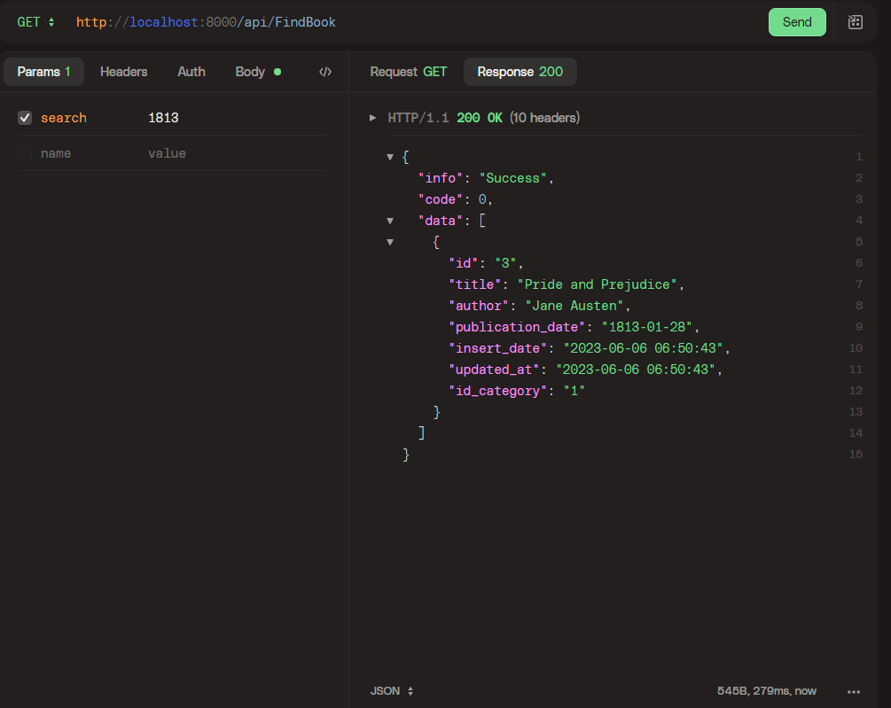

b.Return Kosong

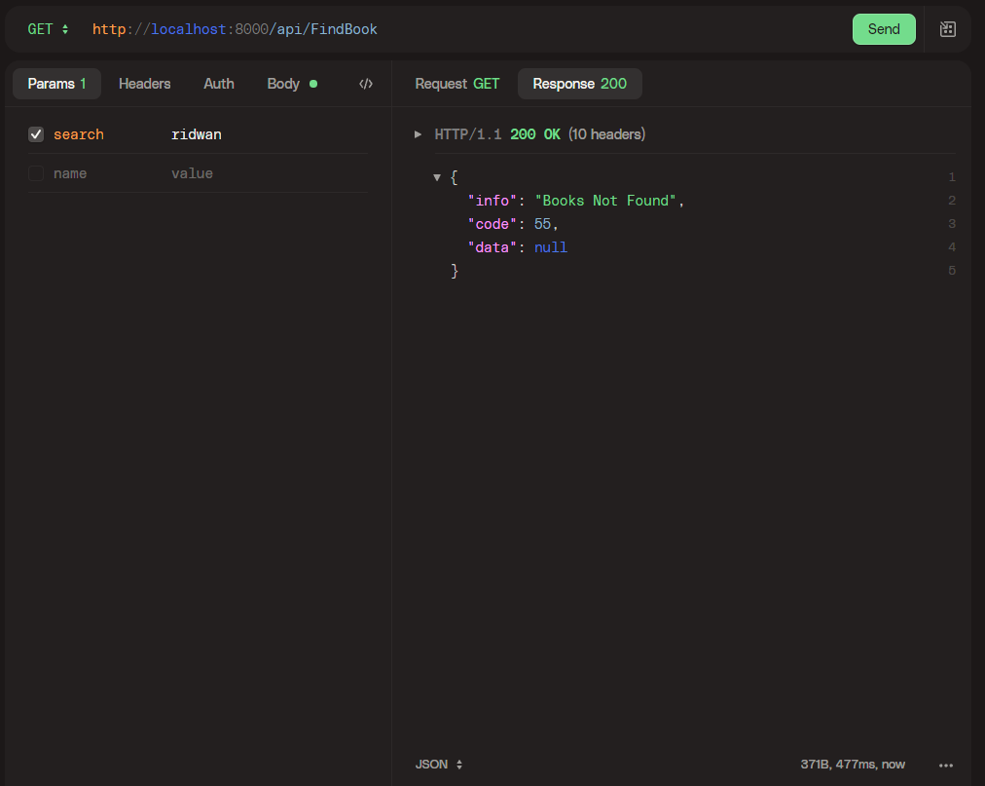

**2.Borrow Book**

url : <http://localhost:8000/api/BorrowBook>  
method : POST  
inputan : -id   
 -username  
 -title  
 -author  
 -publication_date  
 -id_category

output :

a..Return Sukses

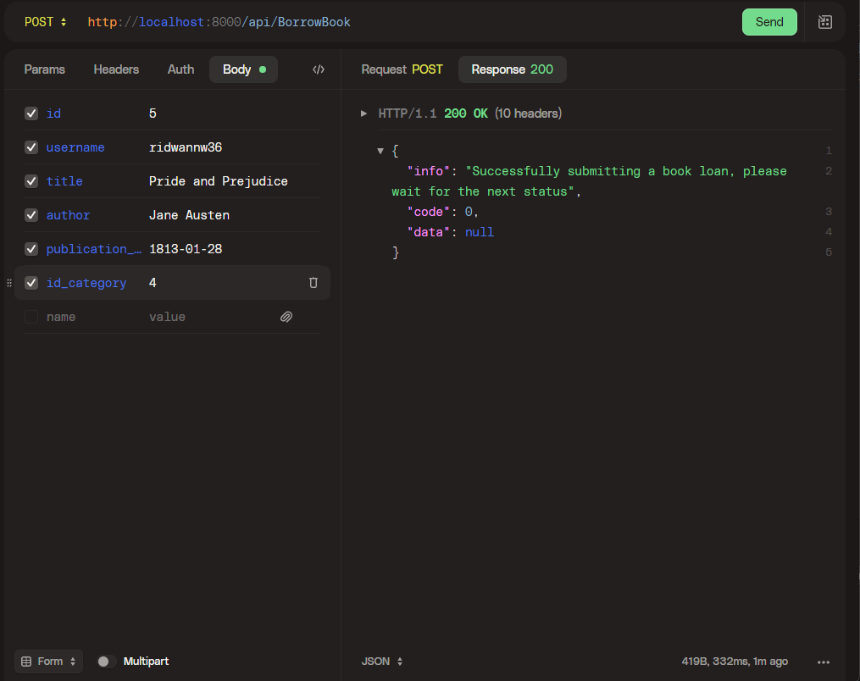

**3.Return Book**

url : <http://localhost:8000/api/ReturnBook>  
method : POST  
inputan : -id

output :

1.Return Sukses

